Investiture Ceremony
“Leadership is the capacity to translate vision into reality”.
The most auspicious ceremonial occasion 'Investiture Ceremony’ of the Shivalik Public School,Phase6, Mohali, was celebrated on 27th July, 2022, with full zeal, zest and enthusiasm. The Investiture Ceremony is one of the momentous occasions when the school entrusts hope, faith and the mantle of responsibility to the newly appointed school cabinet. This ceremony signifies the reliance and confidence that the school consigns in the newly office bearers. The honourable guest Mr D. S. Bedi Director Shivalik Public Schools, graced the occasion. A garland of motivational words by him guided the Student Council Members to be the role models and render their responsibilities sincerely as the nation builders of tomorrow and be proud to be an Indian. He also advised the students to inculcate the values of punctuality, dedication, discipline and determination as they are the torch bearers of tomorrow. He advised the office bearers to work with a spirit of unity in the interest of students at large. He congratulated them and rightly remarked that leadership does not mean enjoyment of one’s power, rather, it is a means to empower others.
The school Principal, Dr. Anupkiran Kaur appreciated the honesty, confidence and clarity in thoughts which the office bearers had exhibited during their selection process and wished that they work not just for the betterment and growth of their fellow students but for their personal growth as well. Academic Coordinator Ms Pooja Piplani advised the Student Council members to be humble and remain in gratitude because they are on the threshold of a new beginning, and the values and ethos that they have imbibed from the school will guide them forever in their lives.
The school Head Boy Gurkirat Singh of Class XII, Head Girl Sakshi of Class XII along with the Deputy head boy, Deputy head girl, Captains, Vice Captains of all the four houses, Activity Leaders, Sports leaders, Transport leaders and Discipline leaders were conferred with badges, sashes and flags.
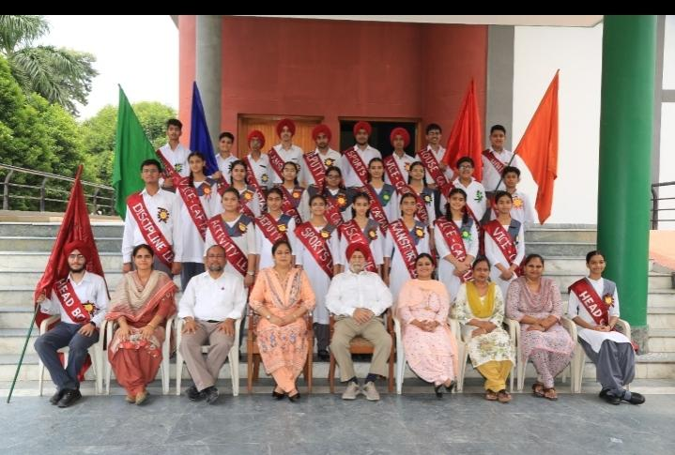
The programme was a grand success.

